Operational Risk
- Reputational risk
Description: Potential damage to brand equity arising from service disruptions, non-compliant behavior by independent third-party drivers, or breaches of user privacy and data protection standards.
- Data Protection and cybersecurity risk
Service outages, platform vulnerabilities, or cyber-attacks.
- Supply constraints and network reliability
Pickme drivers and merchants, conflicts with traditional tuk-tuk drivers, driver protests
Strategic Risks
- Intense competition and easy substitution
- Reliance on key partners and infrastructure
- Regulatory and Policy Risk
Evolving transport regulations, regulatory shifts

Financial Risks
- Fuel Price Volatility
- Cash flow disruptions due to driver misconduct.
- Foreign Exchange Exposure
Emerging Risks
- AI-based impersonation and fraud
- Economic and political uncertainty in Sri Lanka

Operational Risks

O1: Service Quality and Reputational Risk (Medium Impact, High probability)
PickMe faces substantial safety and reputational risk driven by recurring customer complaints, driver misconduct, and weaknesses in dispute resolution, all of which threaten user trust and long-term platform engagement. Numerous incidents recorded on Reddit, TripAdvisor, and social media platforms describe drivers failing to end trips and overcharging passengers. These cases, along with systematic behaviours such as early trip starts and re-registering under new identities after suspension, have created strong public concern about fare manipulation and fraudulent driver practices.
In delivery services, customers report damaged goods, driver negligence, and unresponsive support, undermining PickMe's reliability claims. Compounding the issue, PickMe’s complaint-handling process is frequently described as slow, non-responsive, and evasive, further eroding customer trust.
A customer has been charged with 4,521 instead of LKR 435, due to the driver not ending the ride after drop off. Many tourists are scammed by being charged more than the estimated fare, as seen from a tourist complaint of a Kandy- Ella trip rising from LKR 19,500 to LKR 51,000. One customer has complained that her refund was delayed, extending to 70 days, with inconsistent hotline responses. Customers have also expressed their dissatisfaction with the bidding system and the way the company handles reverse payments.
High-profile cases, including a woman passenger taking legal action after being harassed by a PickMe driver in a mismatched vehicle and a legal dispute over 2% shareholding, raise concerns about corporate responsibility and passenger safety. The harassed passenger later posted this on social media, claiming she will sue PickMe and the alleged driver, which gained massive publicity via newspapers.
Mitigation: Collaborations with George Steuart Insurance brokers. Initiatives, including PickMe Nena Pahana and PickMe Pramuka, enhance the user value. Proactive brand and trust management strategies. Awareness building among independent third-party drivers. Dedicated 24/7 grievance redressal and incident response unit to address real-time issues. Advanced in-app safety features, including allowing passengers to share real-time ride information. Dedicated incident response team for immediate support in case of disputes or incidents. Investments in AI route matching algorithms and infrastructure to improve user experience.

O2: Supply Constraints and Network Reliability (High Impact, Medium probability)
PickMe’s gig-economy model relies on algorithmic management to match drivers with riders and determine compensation. Drivers report a lack of transparency regarding ride assignments, ratings, and pay, creating dissatisfaction and mistrust. Many drivers reject low-paying rides, switch between competing apps, or take cash rides to avoid platform fees. Recent driver protests of PickMe drivers in front of the company, demanding low commissions and high income, have influenced PickMe’s cost structure.

Companies have to invest continuously in driver commissions and incentives to maintain their driver base. The cost of incentives, discounts, and other related costs surged from Rs. 1,213 Mn in 2023 to Rs. 2,937 Mn in 2024, with projections showing further increases. Concurrently, conflicts with traditional taxi operators have resulted in over 30 incidents of vandalism, physical harassment, and injury to drivers, including foreign tourists, within 12 weeks. The company faces difficulties in managing its supply base in taxi mafia areas like Galle and Matara. These safety concerns threaten driver retention, reduce platform reliability, and make it hard for the company to diversify into areas with the taxi mafia.

Mitigation: API based solution for faster driver fund access and improved transaction visibility through partnerships with Standard Chartered Bank. Real-time fraud detection protocols and new credit-card fraud mitigation tools support earlier detection of suspicious driver behavior and avoid revenue leakage. Driver partner programmes to improve awareness of the benefits of digital earnings. Rewarding drivers based on performance and ratings. The company is publicly calling law enforcement authorities for urgent action on driver harassment. Insurance schemes for drivers and their families. Development of PickMe Pramuka through advanced data analytics and machine learning capabilities that utilize real-time performance metrics to categorise drivers into tiers: Platinum, Gold, Silver, and Newbie, ensuring their welfare is integral to the platform's design and functionality. Gold and Platinum drivers receive concessionary insurance coverage provided by an independent third-party Insurance Company valued at Rs. 3 Mn, with cumulative claims exceeding Rs. 40 Mn since 2019 and Rs. 10 Mn in FY24/25.

O3: Technology and Cybersecurity Risk (Medium Impact, Low probability)
The company manages millions of trip records, real-time geolocation data, driver identity details, and customer financial information, making it an attractive target for malware, ransomware, and social-engineering attacks. The company’s privacy policy further states that user information may be transferred to Sri Lanka and other jurisdictions with weaker data-protection regimes, increasing cross-border cybersecurity and compliance exposure.
Under the Personal Data Protection Act (PDPA), any breach or non-compliance could result in administrative fines up to LKR 10 million per violation, with penalties doubling for repeated offences. Public allegations of a large-scale data leak involving up to 4 million user records, including usernames, phone numbers, and hashed passwords, highlight the vulnerability of legacy systems and elevate consumer concerns regarding data stewardship, even though PickMe denies a breach.
Customers also frequently note location inaccuracies, unrealistic routing, and incorrect pickup points, reflecting weaknesses in the app’s mapping algorithms. In addition, PickMe Food and delivery services have experienced periodic downtime, leaving users unable to place orders during peak periods. Users report being charged delivery fees despite holding PickMe Pass subscriptions, pointing to inconsistencies in system logic. More critically, multiple complaints highlight failed payment attempts that still resulted in bank deductions, with no order confirmation.
Mitigation: Dedicated cybersecurity team; regular penetration testing; ISO aligned IT policies; cloud redundancy Systems; tokenization of digital payments. Legal and data protection task force to pre-empt new compliance requirements. Huge investments in Cybersecurity. PickMe management claims to have one of the best Cybersecurity systems in the country.
Strategic Risks
S1: Key reliance on partners and infrastructure (Medium Impact, Medium probability)
PickMe’s business model is heavily dependent on several critical third-party partners, such as Google, Microsoft, and SLT Mobitel, who are particularly cloud service providers, payment gateways, and mapping and communication platforms. Any outage, service interruption, pricing adjustment, or technical failure from these partners would immediately disrupt platform availability, halt bookings, and reduce Gross Transaction Value, directly impacting commission income. Furthermore, failures in external payment infrastructure, such as duplicate charges, unsuccessful transactions, and prolonged refund delays, have already generated notable customer dissatisfaction, revealing the vulnerability of relying on third-party financial systems for core operations.
Beyond digital infrastructure dependency, the company also faces constraints due to Sri Lanka’s limited physical infrastructure; expansion into underserved or rural areas is challenged by inadequate roads, connectivity, and technological infrastructure, which raises operational costs and reduces service reliability. Sri Lanka’s charging network has 100 DC Chargers and 240 AC Commercial chargers operational, owned or operated by four network operators nationwide, but it is still underdeveloped, significantly constraining the adoption of electric vehicles within PickMe’s driver fleet and limiting the company’s long-term ability to transition toward lower-cost, sustainable mobility solutions.
Mitigation:
The company follows strong cloud-management practices and maintains redundancy across its systems, including backup cloud regions and failover infrastructure, to minimise the risk of outages disrupting platform availability. PickMe employs world-class cybersecurity frameworks such as NIST, conducts regular penetration testing, and operates a dedicated cybersecurity team, helping safeguard its reliance on external cloud platforms and payment gateways. To reduce dependency on cash and strengthen digital payment reliability, PickMe partnered with Standard Chartered Bank to implement an API-based real-time settlements system, improving reconciliation and giving drivers instant access to funds.
The platform has also deployed real-time fraud detection protocols and enhanced card-fraud mitigation tools. In parallel, PickMe upgraded its passenger app for greater stability, reporting a 38% reduction in user-reported issues and improving wait times by 11%, thus strengthening resilience against failures in partner systems.
To mitigate physical infrastructure limitations, especially poor rural connectivity and the slow EV-charging rollout, PickMe has expanded its service ecosystem through multi-modal transport options, engaged in EV-adoption initiatives with partners such as Vega Innovations and Rhoda, and continues to build capabilities that support long-term electrification despite national network constraints.

S2: Regulatory and Policy Risk (Low Impact, Low probability)

As of June 2025, BIA has banned app-based vehicles such as sedans and small vehicles operating in official pick-up areas, while it is not banned for other traditional taxi services. This means customers, for convenience, will switch to other substitutes, and it will result in a reduction of airport ride volumes for PickMe.

The sudden surge of digital VAT from 15% to 18% will increase PickMe’s fee structure as VAT is passed down to the end consumer through higher ride rates and price increases, especially on the food and marketplace verticals. Uber is exempt from paying VAT until 2026 due to the postponement of VAT on non-resident digital companies until April 2026. Currently, Uber fees are lower mainly due ot this VAT exemption, and if consumers realize it is cheaper than PickMe, they will switch to Uber. It will impact the demand and cash flow dynamics of the company.

Currently, there is a huge regulatory gap in the industry. Consumer Care Authority has emphasized the importance of regulating this industry loophole to the media after receiving a high number of consumer complaints from the Gampaha and Colombo areas. They even did a study on the industry in 2021, but there is a lack of implementation. NTC has stated that they’re trying to regulate the industry through NTC Act No.8 Amendments, which indicates a regulatory uncertainty for PickMe, but they haven’t been gazetted yet.

A new labour organization called the Federation of app-based transport workers was formed under the Aegis of the Sri Lanka office of the UK-based International Transport Workers Federation (ITF), which included both PickMe drivers. Given that, drivers have complained about not having sick pay and other driver-related regulations, there is a chance that they will demand this via labor unions. While this may improve labor relations if managed proactively, failure to address the federation’s demands could increase costs, disrupt service, and negatively impact profitability and reputation.

Introduction of the Personal Data Protection Act 2022 further increases compliance risk. The Act requires controllers to process data lawfully in compliance with the obligations outlined in Part I of the Act.

The company has future expectations of expanding into school transport service and integrating with public transport service, which are highly regulated areas. Even recently, the education ministry decided to introduce a new set of rules and regulations for vehicles used to transport school children in collaboration with the Transport Ministry, to ensure the safety of school children. Rules will be strictly enforced on all vehicles engaged in transporting school children.

Mitigation: A Robust compliance framework ensures that the company is adhering to all the regulations and policies. The company has taken steps to adhere to PDPA even if it is not regulated by the government. Board-led governance reviews and periodic employee training further mitigate the regulatory risk. Once the VAT on non-resident companies is imposed on Uber, their fees will go up, giving PickMe an advantage.

S3: Intense competition and ease of substitution. (Medium Impact, High probability)

Competitive rivalry in Sri Lanka’s ride-hailing industry is high due to a duopolistic market structure, aggressive pricing tactics, and rapid industry growth that attracts new entrants. PickMe dominates with ~70% market share, followed by Uber at ~25%, yet competition remains intense as both platforms engage in constant price wars, promotions, and driver incentives to retain users. Despite PickMe’s leadership, the market is far from saturated. The sector represents only 2.6% of total mobility volume, with user numbers projected to reach 4.3 million and penetration to hit 19.5% by 2027, encouraging rivals like Uber, Helago, Bolt, Jride, SLT Muve, Taxiyak, Kangaroo Cabs, and Yogo to expand aggressively.

The threat of new entrants is high due to the huge profits earned by existing market leaders and the high industry growth of 8.89%. PickMe’s market share could be threatened if new players grow quickly, as evidenced by Helago having a strong market entry with 500 riders registered in just 24 hours.

Low switching costs and high price sensitivity, where consumers shift apps for differences as small as Rs. 50 –100, further intensifying rivalry, while informal tuk-tuk operators continue to exert strong pricing pressure. Companies also compete through marketing, service diversification, and technological differentiation, from GPS-enabled smart meters (Yogo) to Uber’s advanced safety features and PickMe’s localized super-app model. Together, these dynamics create a highly competitive environment that pressures margins, increases customer acquisition costs, and elevates long-term strategic risk for PickMe.

Sri Lanka’s mobility market is dominated by low-cost alternatives with deep cultural acceptance and strong usage volume. Ministry of Transport data show that three-wheelers account for ~25% of passenger transport, while public bus usage remains one of the cheapest and most widely available travel modes, despite declining from 34.6% in 2019 to 13.6% in 2021. Sri Lankan riders are extremely price sensitive, frequently switching apps for differences as small as Rs. 50 –100, and moving easily between PickMe, Uber, HelaGo, tuk-tuks, buses, and trains due to zero switching costs. Ride-hailing, by comparison, is far more expensive (Rs. 200-1,000+ per trip) versus bus and trains (Rs. 40-150), making price-sensitive Sri Lankan riders highly responsive to even small fare differences. This is evident in consumer behaviour, where riders routinely compare PickMe, Uber, and smaller apps, and will switch providers for savings as little as Rs. 50-100, especially on short-distance rides.
Even in the delivery sector, substitutes such as direct restaurant delivery, informal couriers, and walk-in pickups remain widely used. While PickMe benefits from strong brand recognition, the company operates in an environment where substitutes are abundant, cheaper, and widely accepted across both urban and rural markets.
For investors, this high substitutability reduces PickMe’s pricing power, increases volatility in ride volumes, limits the company’s ability to pass rising costs (fuel, VAT, commissions) to consumers, and elevates long-term revenue risk. The presence of entrenched and significantly cheaper alternatives, supported by quantitative evidence of high substitute usage, thus represents a structural constraint on PickMe’s growth and margin expansion potential.
Mitigation:

Strong localized ecosystem, along with the large network of 100,000 active drivers and the strong business model, gives PickMe a strong competitive edge. Wider coverage through diversification into underserved areas, including Ratnapura and Anuradhapura, increases their market share while other competitors are mainly focused on urban areas. Evolving beyond ride-hailing into multiple vertices (food delivery, logistics, marketplace, events) helps spread risk and reduce reliance on the competitive front. Continuous investments in innovation help adapt to the evolving competitive landscape.

Financial Risk

F1: Fuel Price Volatility (Medium Impact, Medium Probability)

When fuel prices rise, drivers’ earnings are squeezed, leading to increased demands for higher commissions or incentives, pressuring PickMe’s margins and risking driver satisfaction. If not managed carefully, this could result in service disruptions, increased customer fares, or even driver protests, all of which pose a financial burden. While the Central Bank of Sri Lanka (CBSL) shows a recent decline to around LKR 318 per litre, fuel prices remain highly volatile due to global oil prices and inflation. High price surge will require PickMe to adjust its fare structures and incentive models to maintain platform stability. This cost sensitivity, tied closely to fuel prices and inflation, makes sustained profitability uncertain, posing a long-term risk to investor returns and the company's financial resilience. During the fuel crisis period, Platform-wide ride volumes stagnated in FY23, growing just 6.4%, compared to +16.6% in FY22, largely due to fuel-related supply constraints. Any sharp rise in fuel prices would once again squeeze driver margins, prompting PickMe to increase driver incentives and commissions or raise customer fares, which could risk demand elasticity and user attrition.

Mitigation: Dynamic pricing and a data-driven take-rate strategy to adjust its revenue model in response to cost pressures, helping maintain margin stability even when fuel prices increase. Purchase of e-bikes and initiatives on adaptation and awareness of EV vehicles. Diversification into less fuel-incentive three-wheel and bike-based services helps reduce driver cost exposure. Substantial investment in routing and matching technologies has improved vehicle utilisation and reduced idle runs, lowering fuel consumption per trip.
F2: Cashflow disruptions due to driver misconduct (Medium Impact, Medium Probability)

PickMe faces significant revenue leakage arising from various forms of driver misconduct that circumvent the company’s commission and fare-collection systems. A growing number of drivers encourage passengers to complete trips off the app, either by refusing card payments or by cancelling the trip upon arrival and requesting cash instead. When rides are paid in cash, drivers retain the full amount, making it difficult for PickMe to recover the commission owed; this not only contributes to revenue leakage but also creates liquidity pressures and increases the risk of uncollectible receivables and bad debt. Because PickMe earns revenue only on completed in-app transactions, these off-platform cash rides result in direct commission loss for the company. Drivers also exploit loopholes by not starting trips, starting trips early, or ending trips late, actions that distort fare calculations, reduce transparency, and lead to customer disputes, all while undermining proper revenue capture. Persistent revenue diversion through off-app transactions and fare manipulation represents a material financial risk that can compress margins, reduce Gross Transaction Value (GTV), and introduce volatility into future revenue forecasts.

Mitigation:
Real-time fraud detection protocols and new credit-card fraud mitigation tools to avoid driver misconduct. Partnership with Standard Chartered Bank to deploy an API-based solution for faster driver fund access, improved transaction visibility, and reconciliation. Driver-partner programmes to improve awareness of the benefits of digital earnings.
F3: Currency Risk (Low Impact, High Probability)
Depreciation of LKR - PickMe’s operating model is highly dependent on foreign-denominated technology services, particularly Google Cloud, Microsoft, and other IT infrastructure providers. 62% of operating expenditure, such as cloud hosting, software licenses, IT audits, and consultancy services, is payable in US dollars. As the LKR weakens, the cost to pay for the same USD services increases, squeezing revenue margins. This directly impacts profitability since revenues (rides, deliveries) are earned in LKR while some expenses must be paid in US currency.

Mitigation: Increasing scale helps absorb fixed dollar costs while robust treasury policy and periodic stress testing help manage currency exposure. Revenue diversification into multiple services, including Ride, Food, Market, Flash, Trucks, and business rentals, reduces reliance on a single revenue stream, although ride-hailing remains the primary contributor. Strategic partnerships with Google and Microsoft also optimize operational efficiency and partially mitigate cost pressure.
Emerging Risks
E1: AI-based impersonation and fraud (Medium Impact, Low probability)
AI-based impersonation and fraud an emerging risks for PickMe because advancements in generative AI now make it easier for criminals to mimic identities, forge documents, and manipulate voice or image verification systems used in driver onboarding and customer authentication. Fraudsters could use AI-generated IDs, deepfake profile photos, or synthetic voices to register as drivers, bypass safety checks, or deceive passengers, increasing the risk of scams, harassment, or criminal activity on the platform.
On the payments side, AI-driven social-engineering attacks and real-time voice impersonation could trick users into sharing OTPs or authorising fraudulent transactions. For PickMe, these threats heighten exposure to safety incidents, reputational damage, regulatory scrutiny, and financial losses, making continuous investment in advanced fraud-detection tools, biometric validation, and real-time AI monitoring essential.
Mitigation: The Company’s responsive strategy focuses on strengthening identity verification protocols and AI abuse detection tools. Enhanced card-fraud mitigation tools and cloud-level security controls further reduce the likelihood of AI-enabled payment scams or impersonation attempts.
E2: Economic and political uncertainty in Sri Lanka (Low Impact, Low probability)
Disruptions in the political environment have repeatedly shown the ability to directly suppress mobility demand, destabilize driver supply, and increase operational costs. Any renewed fuel shortages, curfews, protests, or transport disruptions similar to those seen in 2022 would immediately reduce ride volumes, weaken driver supply, and slow activity across PickMe Food, Flash, and trucking. Inflationary pressures and further LKR depreciation would raise the cost of PickMe’s USD-denominated cloud and software expenses, compressing margins and forcing fare adjustments that price-sensitive riders may resist. Political shifts in transport regulation, labour classification of gig workers, or tax policy (e.g., VAT increases) could elevate compliance costs and reduce profitability. Prolonged uncertainty also reduces consumer spending power, making riders more likely to choose cheaper substitutes such as buses or tuk-tuks, lowering Gross Transaction Value and commission income. These factors mean future instability can quickly disrupt PickMe’s nationwide operations, tighten liquidity, and introduce earnings volatility, posing a material strategic and investor risk.
During the 2022 economic collapse characterised by inflation exceeding 70%, sharp LKR depreciation, and nationwide fuel shortages, PickMe’s ride volumes contracted significantly as both riders and drivers reduced activity; ride-hailing demand plummeted virtually overnight, and revenue declined steeply in FY2022 as mobility froze. The company’s financials reflect this shock. Net revenue only began recovering after the crisis, surging 350% from FY2022 to FY2025 as fuel availability improved and consumer mobility returned.
Political unrest and curfews during 2022 similarly halted mobility and food delivery operations, demonstrating how sensitive the platform’s revenue is to national disruptions. Even after stabilisation, macroeconomic volatility remains a risk. Cloud services and IT licences billed in USD account for 99.6% of PickMe’s operational expenses, meaning every 10% LKR depreciation directly inflates costs and compresses margins. Although demand rebounded in FY2025/26, with Q1 revenue growing 50% YoY, this recovery underscores the platform’s exposure to macro conditions rather than immunity. Overall, economic and political instability can quickly reduce transaction volumes, raise operating costs, and create revenue volatility, presenting a significant risk to PickMe’s earnings trajectory and investor confidence.
Mitigation: The company’s asset-light model, with total assets of only LKR 4,024 million against revenue of LKR 5,800 million, lowers fixed-cost exposure during macroeconomic shocks. The company’s strategy focused on Scenario planning and contingency reserve strategy

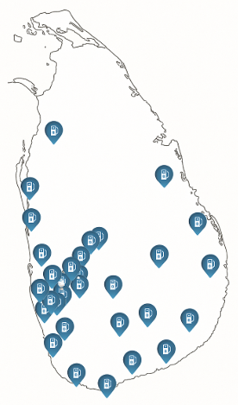
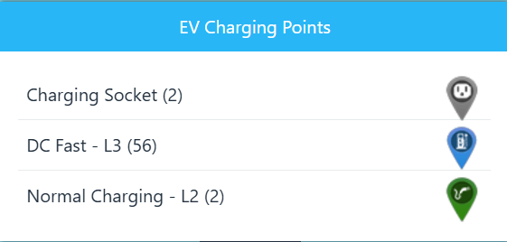
Availability of EV infrastructure

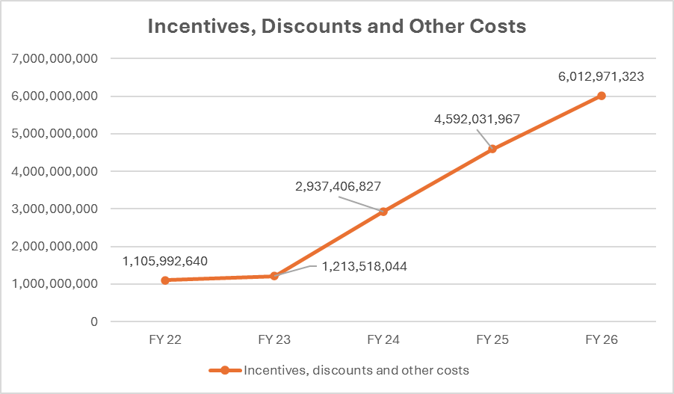
Cost sensitivity to incentives and commissions

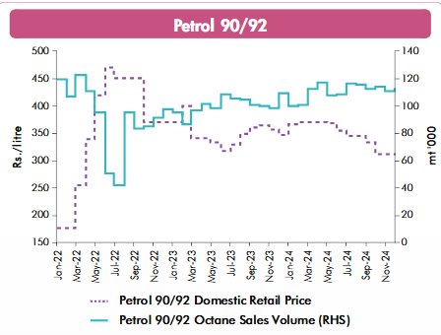

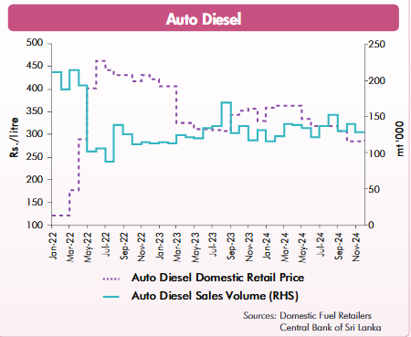

Risk Heat Map
Risk Matrix
Senstiivty Analysis

